# Lab 3.2 Develop the Income Tax Calculator

~~In this exercise, you’ll use nested if statements and arithmetic expressions to calculate the income tax that is owed for a taxable income amount. When a user enters their taxable income and clicks the Calculate button, this application will display the income tax owed.~~

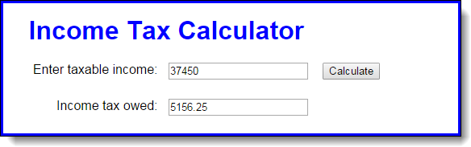

~~This is the table for the federal income tax on individuals that you should use for calculating the tax:~~

|  |  |  |  |
| --- | --- | --- | --- |
| **~~Taxable income~~** | | **~~Income tax~~** | |
| **~~Over…~~** | **~~But not over…~~** |  | **~~Of excess over…~~** |
| ~~$0~~ | ~~$9,225~~ | ~~$0 plus 10%~~ | ~~$0~~ |
| ~~$9,225~~ | ~~$37,450~~ | ~~$922.50 plus 15%~~ | ~~$9,225~~ |
| ~~$37,450~~ | ~~$90,750~~ | ~~$5,156.25 plus 25%~~ | ~~$37,450~~ |
| ~~$90,750~~ | ~~$189,300~~ | ~~$18,481.25 plus 28%~~ | ~~$90,750~~ |
| ~~$189,300~~ | ~~$411,500~~ | ~~$46,075.25 plus 33%~~ | ~~$189,300~~ |
| ~~$411,500~~ | ~~$413,200~~ | ~~$119,401.25 plus 35%~~ | ~~$411,500~~ |
| ~~$413,200~~ |  | ~~$119,996,25 plus 39.6%~~ | ~~$413,200~~ |

1. ~~Open the HTML and JavaScript files in this folder:~~

~~\income_tax\~~

~~Note that the JavaScript file has some starting JavaScript code for this application, including the $() function and a DOMContentLoaded event handler that attaches a function named processEntry() to the click event of the Calculate button and moves the focus to the first text box.~~

1. ~~Code the processEntry() function. It should get the user’s entry and make sure it’s a valid number greater than zero. If it isn’t valid, it should display an error message.~~ If ~~it is valid, it should pass the value to a function named calculateTax(), which should return the tax amount. That amount should then be displayed in the second text box. The focus should be moved to the first text box whether or not the entry is valid.~~
2. ~~Code the calculateTax() function. To start, just write the code for calculating the tax for any amount within the first two brackets in the table above. The user’s entry should be converted to an integer, and the tax should be rounded to two decimal places. To test this, use income values of 9875 and 40125, which should display taxable amounts of 987.50 and 4,617.50.~~
3. ~~Add the JavaScript code for the next tax bracket. Then, if you have the time, add the JavaScript code for the remaining tax brackets.~~